

**Project report**

**Project name : Online Abmission Management System**

**Project done by**

|  |  |  |
| --- | --- | --- |
| **Name** | **REG NO:** | **Roll No:** |
| **Nadipudi praveen** | **11911874** | **01** |
| **Karra preetham** | **11910281** | **34** |
| **Syedd jafar hussain** | **11912935** | **68** |

**Submitted to**

**Student Declaration**

This is to declare that this report has been written by me/us. No part of the report is copied from other sources. All information included from other sources have been duly acknowledged. I/We aver that if any part of the report is found to be copied, I/we are shall take full responsibility for it.

**TABLE OF CONTENTS :**

1. **Abstract**
2. **Introduction**
3. **BACKGROUND AND RELATED WORK**
4. **PRESENTATION OF THE MAIN CONTRIBUTION OF THE /SCOPE OF RESEARCH**
5. **PROPOSED METHODOLOGY AND DISCUSSION**
6. **EXPERIMENTAL RESULTS**
7. **CONCLUSION**
8. **ACKNOWLEDGMENT**
9. **REFERENCES**

**ABSTRACT**

Online College Admission Management System is software developed to work on web-platform to manage the complete admission procedures of various departments of an institution like, Finance Section Administration, Student section and many more sections. Over the years that the process of admission, notice boards, important declarations about academics and administrations are being carried out manually through paper and pen which is very time consuming and really a big headache to maintain all that record at some place. .This paper-pen process is not only time consuming but also inefficient and it’s difficult to maintain the paperwork and the records. Through this software we are trying to overcome the problem of maintaining paper based records and focussing on the digital library. In addition to record based technology, we would be sending pushin notifications given by the institutes and the very same portal would be again used to notify the students and even the parents about the announcements digitally. Keeping all these points in mind, we have developed a web tool which is implemented using web-services that would connect with the database established on a remote server. The Unique PRN would provide unique identification to all the students who would be using this system. PRN Number would not just help the admin to keep the track of students, but would make it easier for the students as the student don't have to go through the pain of submitting multiple hard copies of the documents and proofs each time the institution requires it. Automated Online College Admission Management System is a simple yet effortful tool that would result in reducing the paper-work easy for the institutions as well as the students who would use it.

**INTRODUCTION**

In today's time, inspite of technology advancement still all the admission process be it be the college or school admission it is being carried out manually using paper and pen which is very inefficient and utilizes much efforts and time. In this present century of technology where computers are being used everywhere, they are being used as an alternative to pen and paper. The database can digitally store more information about users in less space and in very less time the very basic principle behind the necessity automated college online admission system is peaceful observation of institutes. This tool can easily store the details of students such as fee details, documents details and admission details. This Student Database has been designed taking considering the practical needs to manage a Students data. Its design focuses on 2 types of users: • Admin • Students The Database follows a unique event flow developed for such a system. Communication between the student/parents and the institution management is the sole purpose of this software along with reducing the paper work to some extent. This system benefits the administrator to access and verify the information of students. This Automated Online College Admission Management system benefits the administrator as he can send pushing notifications and make announcements which are directly received by the students and parents. The concept of Personal Registration Number or PRN is also included using which the each student gets one inimitable Identification. This id will help in future to access information or find student among several students of the college.

**II. BACKGROUND AND RELATED WORK**

The main aim of our project is to advance the application which will be useful in college admission system. As Automated Online College Admission Management System Project comprisesthe rank allotment, documents upload, admittance procedure of student initial from when the student takes admittance in college in first year to final year of the student. The requisite of the student is to: • Login to the system through the first page of the application. • View/change his/her details. • Can get help through the help of choice to view different features of the system. • Admin login is present through which the official person can verify the details, modify and update the branches and maintain the students information

**III.** **PRESENTATION OF THE MAIN CONTRIBUTION OF THE PAPER/SCOPE OF RESEARCH**

a) **Problem definition** In today’s scenario the counselling of student Admission is done manually through hands by ink and paper, which take large amount of time and causes strain and struggle for the administration. It is important and needed to Design an online Student Admission management System, to pace up the work and make it easy way to use system By shrinking those drawbacks we create a web based application for handling the admission of the students. This is an online system which includes firstly the admission of new student and by giving their preferred branch according to their CET rank and by verifying and validating students documents and by continuing it to further process by generating the fee payment receipts, documents and saving it with the scanning and uploading the student’s permanent unique id provided.

b) **Objective** Why we making this online system is to reduce the work load and easy the process and to give the desired functionality ingesting of time during the keeping the records of college admission procedure The main objective in online Examination is main Counselling system is to offer an approach for easy and fertile management of all components included in counselling. As developers We have perceived the information as : • To provide a counselling provision for the students. • It manages the database of the students on the basis of higher secondary results, rank and their PRN. • To assign branches according to merit list prepared according to their common admission test result..

**IV. PROPOSED METHODOLOGY AND DISCUSSION**

**a) Need of proposed system** The need of this system is to maintain a proper userfriendly communication. The scheme, which is created, now generates all the details that are recalled manually. Once the details are saved into the system there is no need for numerous persons to deal with distinct sections. Only a particular person is enough to preserve all the reports. The haven can also be given as per the implementing needs of the user and those needs are: big volumes of data can be stored with easy.. Records stored are modified with much ease without taking numerous efforts. Stored data and procedures can be easily modified .smooth calculations are done, and the Main important benefit from this system is it provides a good way of managing time

**b) System design** This play with how the data flow through the various processes, comprehensive and detailed flow graph and the procedure flow of the front end and back end make of the student information running system. There is one database which deals with student section, student counselling process which holds its verification and validation process and admin section which holds the authorities for all the processes to be implemented.

c) The detailed flow graph The implementation of the student information running system comprises of the thing in an better implemented way and large amount of work can be done in less interval of the creativity of the home page whichgives the best interface for all the students, and admin login. Every user has its own unique username and password provided by the college authorities. The home page mainly contains a login through which student and admin can login to follow it to further way

**V.** **EXPERIMENTAL RESULTS**

It is an online system for our college of the university. It comprises of admin and student units. Each subunit of office is a great helping hand for providing the actual processes for student like student and account. Executed outcome result of our College student's admission will be done online and by verifying and validating the documents of the scanned copy by each of the student online by admin authorities. Each and every process comprises of the requirement of our project that are going to be executed in an better implemented way.

1. **Login module**: Input will be particulars of students like academic summary, particular etc. though satiating the admission form. the receipt of conformation will be there to plaid to check the student gets the conformation about the details he gave . The functionalities of the administrator and student are stated and fruitfully tested.

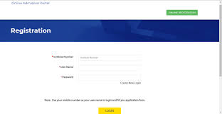

1. **Branch allotment module:** That admission procedure will be processed with student’s documents verification and fee specifics and admittance of the student will get confirmed. And all the student details will be retrieved whenever any department or college section or unit wants it as per what they. The student will gets conversant by message by the college sector about their conformation report.

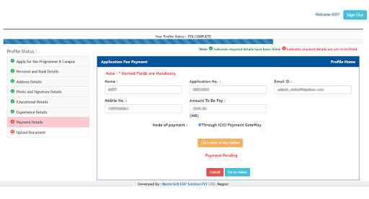

1. **Analysis of the database**: After going through the admission procedure student will go for documents uploading and here the checker will enter the PRN No. provided by Admin section. There afterauthentication of the form will be verified and validated by admin units of the college and after the whole completion of counselling process a branch wise list will be prepared with detailed information of student which will ease the work of the department and their faculty to furthermorestages.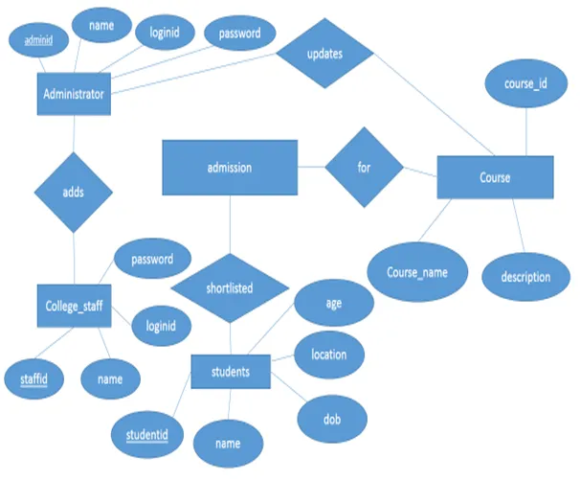

**VI.** **CONCLUSION**

By this project we are making to heighten and implement the improvements in college counselling system, which is good and an easy way for reduce in hand work and making less handwork necessary. Students’ database can be retrieved within quick interval of time proper maintaining of records can be achieved. Our system presently aims on creation of an good management system for the college universities. system will solve the problem of seat status by showing dynamic display of the seat status after every session of counselling, so that student can select their seat preference accordingly in an hassle freeway which will make a clear impact for selecting their desired branch in an quick interval of time. This online counselling management system will do the best for the needful who are at very large distance and will clear information about the process so that counselling can be implemented in an smooth way and by reducing the efforts and by increasing the efficiency in the college work process.

**ACKNOWLEDGMENT**

When the compilation of research paper comes to an end, the time comes to acknowledge all the persons who have made its success possible. It gives us immense pleasure to express our gratitude to each individual associated directly or indirectly with the successful compilation of the research paper. Our deepest gratitude is to our guide, Prof. A.K. Kadam for his valued support and guidance. We will forever remain grateful for his valuable help and inspiration. The valuable discussion we had with him, the penetrating questions he had put to us, has all let to development for this Research paper. We are also grateful to Prof. Naveen Kumar for his upkeep and guidance that have helped us to reach our horizons of thought and expression. we wish to thank Head of Department, computer Engineering Prof. Dr. D.M. Thakore, for this timely advice, guidance, and motivation. He presented the new innovative ideas in front of me. We humbly thank principal, Prof. Dr. Anand Bhalerao for his valuable coordination and support. He provided us with various facilities. At last we express our heartfelt t gratitude to all friends and faculty members of Computer Engineering Department who assisted us indirectly during this course of work.

**REFERENCES**

[1] HuixiaWang,HuiZan “methodologies of student information management system.” 2010 report on college information processing.978-0-7695- 4196-9/10 IEEE. [2] Zhi-gang YUE, You JIN, “The development and design of the student management system based on the network stratergies”,2010 International Conference on management system , 978-0- 7695- 4136-5/10 2010 IEEE. [3] N. F. Col, (2007). Using Internet technology to improve and simplify counseling about university: The WISDOM website. Maturitas , 57, 95-99. [4] M.A. Norasiah and A. Norhayati. “Intelligent student information system”.4th International conference on computer technology proceduress, Shah Alam , Singapore , 0-7803-7773-7/03 2003 IEEE. [5] Qiu Chang-li 2 Li Jing 3. “The developing procedures of student information counselling system based on B/S architecture”. 978-1- 4577- 1415-3/12 2012IEEE [6] S.R.Bharamagoudar1, Geeta R.B.2, S.G.Totad3 “Student online counselling system International Journal of Advanced Research in Computer Engineering Vol. 2, Issue 6, June 2013. [7] B. Stein, (2000). Learning information Management System (LIMS) Solution for WebBased counselling system (WBCS). Abgerufen am 19. Jan. 2008 von White Paper:

BONAFIDE CERTIFICATE

Certified that this project report “online admission management system “ is the bonafide work of “nadipudi praveen, karra preetham , jafar Hussain” who carried out the project work under my supervision

<<signature of the supervisor>>

<<name of supervisor>>

<<academic designation>>

<<id of supervisor>>

<<department of supervisor>>